**3.1 Learning\***

* **Habituation**: becoming used to a stimulus
* **Dishabituation**: recovery of a response to a stimulus after habituation has occurred, usually due to the intervention of a second stimulus

Associative Learning

* A way of pairing together:
  + Stimuli and responses (classical conditioning)
  + Behaviours and consequences (operant conditioning)

Classical Conditioning

* Unconditioned stimulus produces an instinctive, unconditioned response
* Unconditioned response paired with neutral stimulus
* With repetition, neural stimulus becomes conditioned stimulus that produces a conditioned response (**acquisition**)

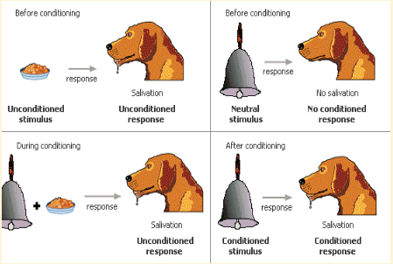

* Dog becomes habituated to the conditioned stimulus i.e. always not getting the meat → **extinction**
  + Hence the conditioned stimulus must be presented with the unconditioned stimulus enough times
  + **Spontaneous recovery**: extinct conditioned stimulus can lead to a weak conditioned response
* Generalization
  + A broadening effect by which a stimulus similar enough to the conditioned stimulus can also produce the conditioned response
  + E.g. scared of white rat → also scared of white stuffed rabbit, white sealskin coat
* Discrimination
  + Opposite of generalization; organism learns to distinguish between two similar stimuli
  + E.g. Pavlov’s dogs will only respond to bell of one tone, but not the other

Operant Conditioning

* Behaviour is changed through the use of consequences

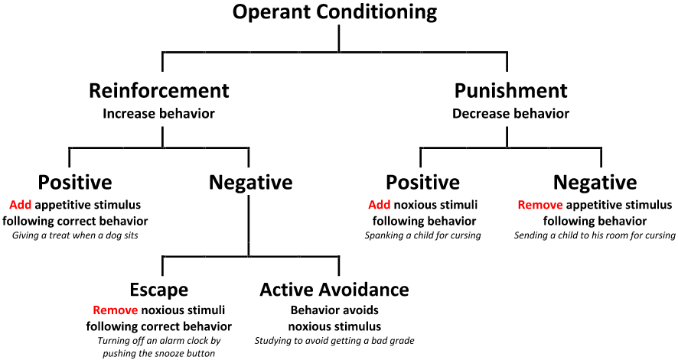

* Reinforcement Schedules
  + **Variable ratio >> Fixed ratio >> Variable Interval >> Fixed Interval**
  + **Variable-ratio** works the fastest for learning a new behavior, and is also the most resistant to extinction
  + **Shaping** is the process of rewarding increasingly specific behaviors → can train extremely complicated schedules

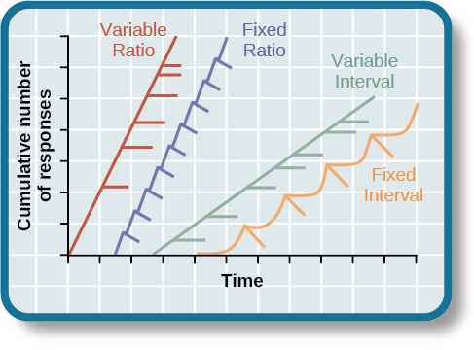

Cognitive and Biological Factors in Associative Learning

* Latent learning
  + Learning that occurs without a reward but that is spontaneously demonstrated once a reward is introduced
* Problem solving
  + Method of learning that steps outside the standard behaviourist approach
  + Trial and error
  + Step back and analyze
* Natural instincts
  + **Preparedness**
    - Learn behaviors that coincide with their natural behaviours
    - e.g. rewarding bird with food for their pecking-based behavior
  + **Instinctive drift**
    - Difficulty in overcoming instinctive behaviour
    - e.g. raccoons cannot pick up coins and dip them into the bank, because they would pull back out according to their natural food-gathering instinct

Observational Learning/ Modelling

* The process of learning a new behavior or gaining information by **watching others**
* Mirror neurons

**3.2 Memory\***

Encoding

* The process of putting new information into memory
  + Can be automatic or effortful
* Semantic encoding >> acoustic encoding >> visual encoding
* Memorization methods
  + Mnemonics: acronyms or rhyming phrases
  + Serial-nature → memorize large lists of objects in order
    - Method of loci: associating each item in the **list with a location** e.g. eggs in living room
    - Peg-word: associates numbers with items that **rhyme** with or resemble the numbers e.g. three trees
  + Chunking: take individual elements of a large list and grouping them together into groups of elements with related meaning
  + Self-referencing (e.g. imaging yourself as the main character talking to the general when learning history, or preparing to teach)
  + Spacing (e.g. 5 x 1h study sessions instead of 1 x 5h study session)

Storage

* **Sensory** and **short-term memory** are transient and are based on neurotransmitter activity
  + Sensory: Partial procedures → able to recall any row or column of an array of nine numbers in great detail, but only immediately after presentation
  + Short-term: serial position effect, 7士2 rule
* **Working memory** requires short-term memory, attention and executive function to manipulate information e.g. mathematical operations
* **Long-term memory** requires elaborative rehearsal, and is the result of neuronal connectivity
  + Explicit (declarative memory): facts and stories
    - Semantic memory: facts
    - Episodic memory: experiences
  + Implicit (nondeclarative) memory
    - Procedural (e.g. remembering how to ride a bicycle)
    - Priming (previous experience influences your current interpretation of an event e.g. hearing “HARE” as “HAIR” because the latter is more common)

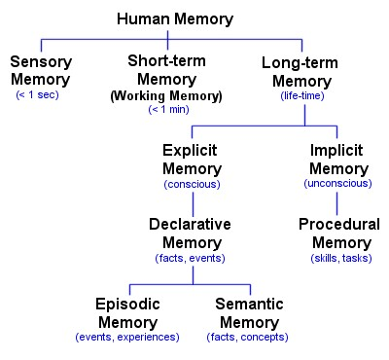

Retrieval

* Recognition of information >> recall
* Often based on priming interconnected nodes of the **semantic network**
  + E.g. red → fire engine → truck ….
* Retrieval cues
  + Priming
  + Context effect (**external**)
    - You score better if you take the exam in a place you learn the info from
  + State-dependent effect (**internal**)
    - Better recall/ proficiency for the tasks when performed in that same mood again
  + Serial position effect
    - Primacy and recency effect

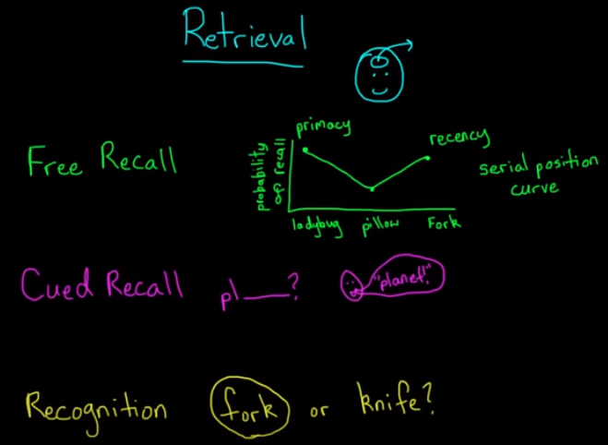

Forgetting

* Brain disorders
  + Alzheimer’s disease
    - Marked by progressive dementia (**loss of cognitive functions**)
    - Retrograde fashion
    - Linked to a **loss of acetylcholine** in neurons that link to hippocampus
  + Korsakoff’s disease
    - Caused by thiamine deficiency in the brain
      * Thymine is important for converting carbohydrates into glucose and therefore normal functioning of neurons
    - Marked by **both retrograde amnesia** (the loss of previously formed memories) **and anterograde amnesia** (the inability to form new memories)
    - **Confabulation**: creating vivid but fabricated memories to fill in the gaps of missing memories
* Decay
  + Memories are lost naturally over time as the neurochemical trace of a short-term memory fades
  + However, relearning a certain piece of information might take less time since some of it is stored in your long term memory (called savings)
* Interference
  + Proactive interference: **old info interfering with new learning**
    - E.g. you have a very old password that you always use, making it hard for you to remember your new password
  + Retroactive interference: **new info causing the forgetting of old info**
    - E.g. you have a new address, causing you to forget your old address
* Aging and Memory
  + Aging does not necessarily lead to significant memory loss!

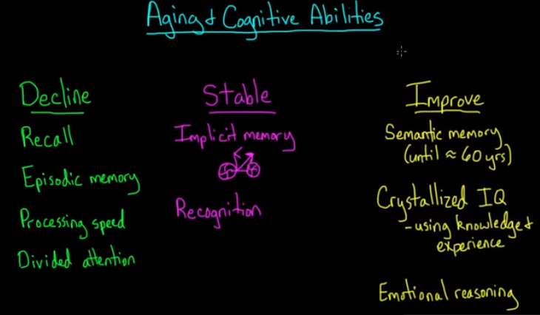

Memory Construction

* Heavily influenced by our thoughts and feelings both while the event is occurring and later during recall
* False memory: a psychological phenomenon where a person recalls something that did not happen or that something happened differently from the way it actually happened
* Confabulation: creation of false memories
* Misinformation effect
* Source-monitoring effect: confusion between semantic and episodic memory
  + Person remembers the details of an event, but confuses the context under which those details were gained
* Flashbulb memories: highly emotional, whether positively or negatively valenced, memories that feel extremely vivid

**3.3 Neurobiology of Learning and Memory**

* Neuroplasticity: ability of the brain to **form new connections rapidly**
  + Decreases with age
  + Easier for a child to learn a new language than it is for adults
  + Brains of young children are so plastic that they can reorganize drastically in response to injury
* Synaptic pruning
  + Weeds off weak neural connections, and strengthen the strong ones
* Long-term Potentiation
  + Responsible for the conversion of **short-term to long-term memory**
  + Strengthens neural connections resulting from:
    - Increased neurotransmitter release
    - Increased receptor density